**😊 AWS Polly**

AWS Polly is a cloud service from Amazon Web Services that converts written text into lifelike speech, enabling developers to integrate voice interaction capabilities into their applications. Using deep learning models, Polly produces high-quality speech in a variety of languages and voice styles, offering both standard and advanced neural text-to-speech (NTTS) options.

**Key Features of AWS Polly:**

1. **Multiple Languages and Voices**:
   * Polly supports over 60 voices across more than 30 languages. This includes male, female, and childlike voices, catering to global user bases.
2. **Neural Text-to-Speech (NTTS)**:
   * NTTS is an advanced speech synthesis technique that offers more natural-sounding voices, reducing robotic tones common in traditional text-to-speech systems. This makes Polly’s speech output more engaging and humanlike.
3. **Real-Time Speech Generation**:
   * Polly can convert text to speech in real-time, allowing applications to generate speech dynamically, ideal for use cases like customer service chatbots, voice-activated assistants, or news readers.
4. **Customization with SSML (Speech Synthesis Markup Language)**:
   * Developers can control aspects like pronunciation, intonation, and pacing using SSML tags. For instance, you can adjust the pitch, volume, and speech speed to create more personalized and suitable voice outputs.
5. **Lexicon Support**:
   * Polly allows users to upload lexicons, which are custom dictionaries that define the correct pronunciation of specific words, names, or jargon, ensuring speech accuracy for specialized vocabulary.
6. **Speech Marks for Synchronization**:
   * Polly provides speech marks (timestamps of words, sentences, and phonemes) that help synchronize speech with visual media. This is useful for applications involving video narration, subtitles, or lip-syncing animations.
7. **Audio File Storage**:
   * Polly enables the saving of speech output as audio files in formats such as MP3, OGG, and PCM. These files can be stored for later use, for example, in podcasts or e-learning modules.
8. **Cost-Effective and Scalable**:
   * Being a fully managed AWS service, Polly automatically scales to handle large volumes of text-to-speech requests, making it cost-effective for high-demand applications.

**Use Cases for AWS Polly:**

* **Voice Assistants and Chatbots**: Polly powers conversational AI systems in virtual assistants, providing natural voice interactions for customer support.
* **Audiobook and Podcast Creation**: Polly can read articles, stories, or even books, automating the process of content-to-audio conversion.
* **E-Learning Platforms**: Polly narrates educational material, making content more accessible for auditory learners and visually impaired users.
* **Smart Devices**: Internet of Things (IoT) devices use Polly for voice output, enhancing user interaction with devices like smart speakers and home automation systems.
* **Content Localization**: With its multi-language support, Polly helps companies localize content by converting text into speech in various languages.

**How AWS Polly Works:**

1. **Text Input**: You provide the input text via an API request or a web-based console.
2. **Text Processing**: Polly processes the text and applies speech synthesis models to convert it into lifelike speech.
3. **Voice Output**: The generated speech can be streamed in real time or saved as an audio file for later use.

**Advantages of AWS Polly:**

* **Engagement**: Converts written content into spoken words, enhancing user experience and accessibility.
* **Customization**: Developers can fine-tune speech characteristics like intonation, emotion, and pace.
* **Flexibility**: Polly’s API makes it easy to integrate with a wide range of applications, from mobile apps to multimedia content.
* **Global Reach**: Extensive language support enables businesses to reach diverse, global audiences.

AWS Polly is widely used for creating interactive voice experiences, making digital content more accessible, and providing natural-sounding speech across a wide array of industries.

**😄 To begin with the Lab:**

1. Login to AWS Console and search for Amazon Polly and from its dashboard choose Try Polly.

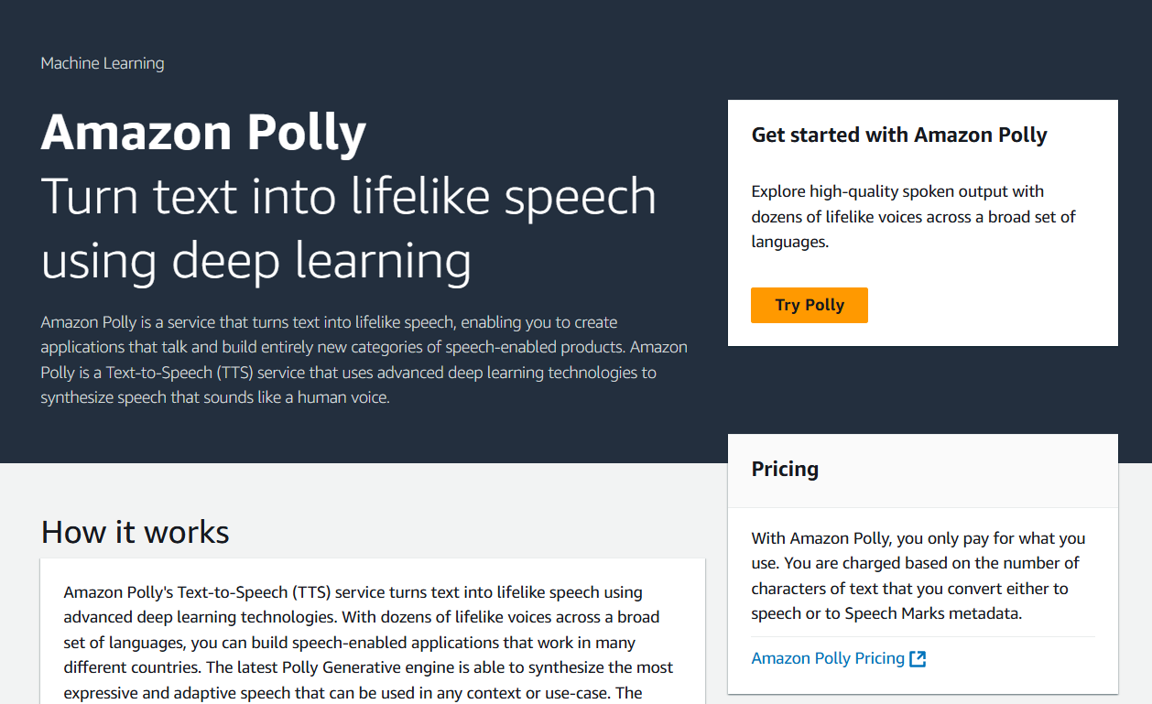

1. This is how the editor would look like. So, this is text to speech IDE.
2. Here you can see that we have to choose the Engine Neural or Standard based on your preference.

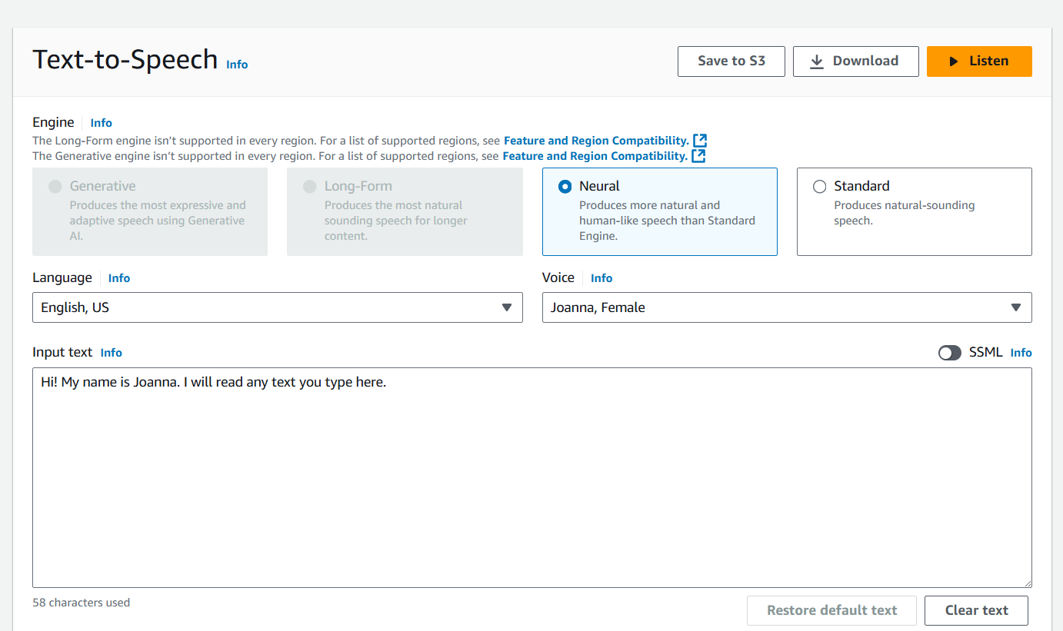

1. Now what you can do is in the Input text area write a statement of your choice and click on Listen.
2. You can choose either Neural or Standard engine type based on your choice and they will sound different.
3. Also, you have the option to change the language type and the voice character.
4. If you click on download then you can download this input text in audio format to listen to it later.

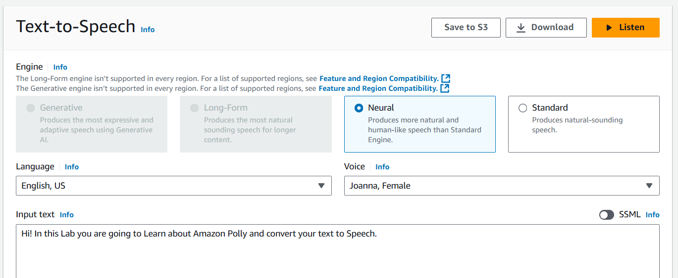

1. If you click on Save to S3 option then here you have the ability to save this audio to your desired S3 bucket.

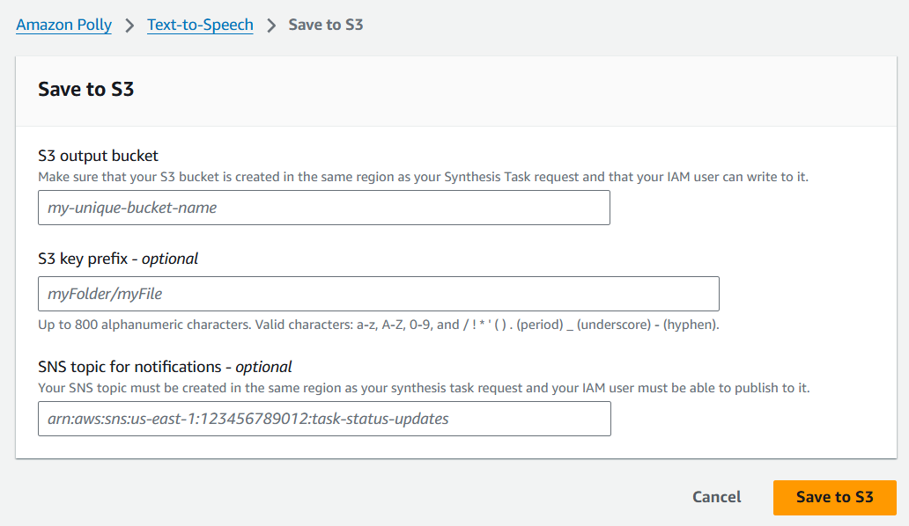

1. You can also turn on SSML (Speech Synthesis Markup Language) to check difference between different options.

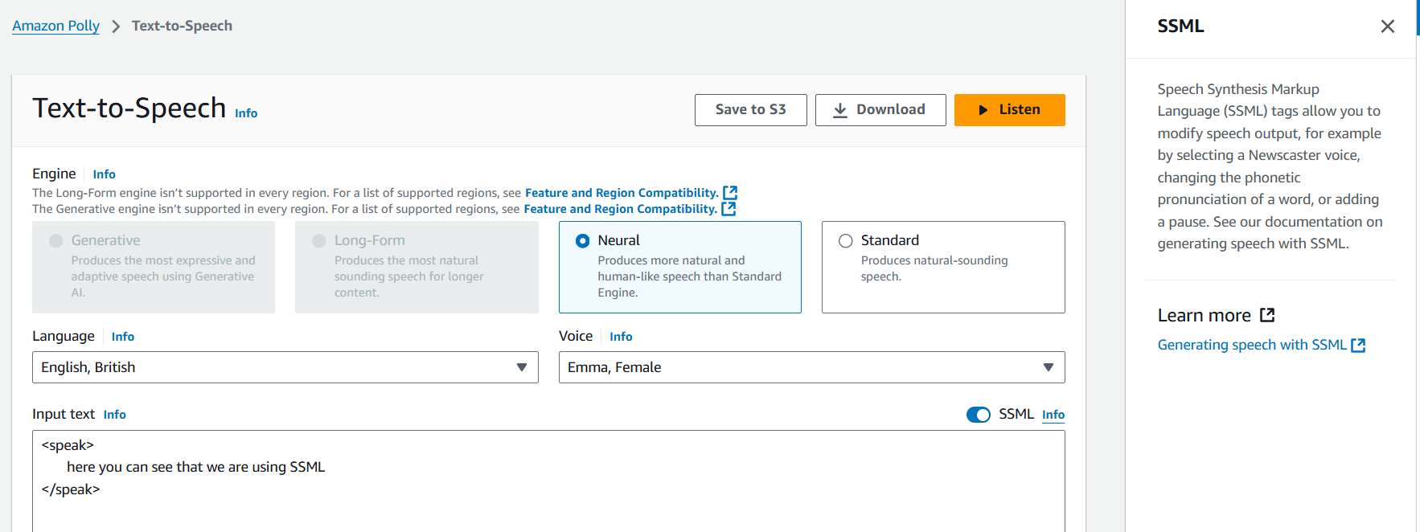

1. Below you can see that you have the code for it. I’ be providing multiple codes to try out SSML.
2. If you get any errors saying not invalid syntax just change the engine or voice.

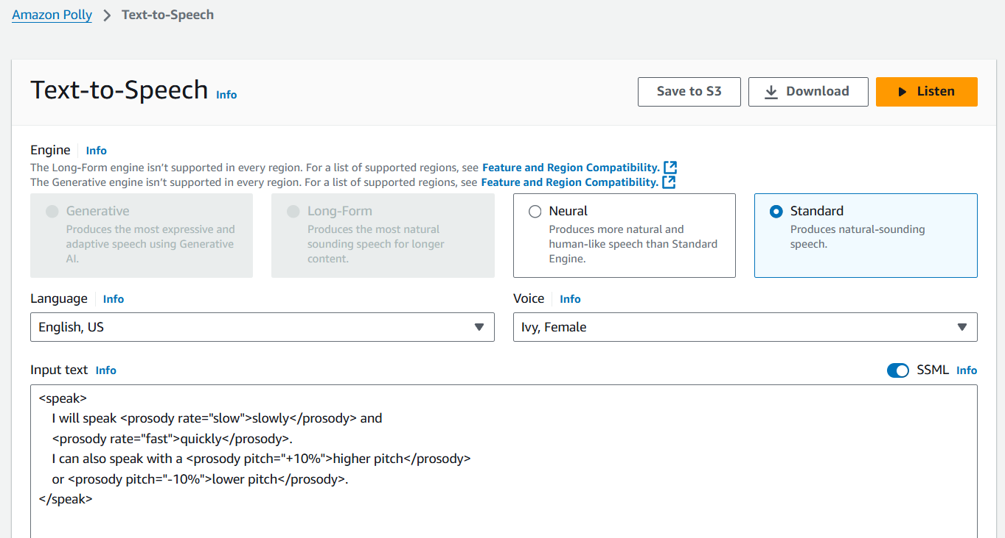

**<speak>**

**Hello! Welcome to our service.**

**<break time="500ms"/>**

**We are here to assist you.**

**<emphasis level="strong">How can we help you today?</emphasis>**

**</speak>**

**=================================================================**

**<speak>**

**I will speak <prosody rate="slow">slowly</prosody> and**

**<prosody rate="fast">quickly</prosody>.**

**I can also speak with a <prosody pitch="+10%">higher pitch</prosody>**

**or <prosody pitch="-10%">lower pitch</prosody>.**

**</speak>**

**=================================================================**

**<speak>**

**Welcome to <phoneme alphabet="ipa" ph="ˈæməzən">Amazon</phoneme> Polly.**

**</speak>**

**=================================================================**

**<speak>**

**I can speak <prosody volume="loud">loudly</prosody> or**

**<prosody volume="soft">softly</prosody>.**

**<amazon:effect name="whispered">I can also whisper like this.</amazon:effect>**

**</speak>**

**=================================================================**

**<speak>**

**The next step is <break time="1s"/> a critical decision.**

**Please <break strength="strong"/> take a moment to think.**

**</speak>**

**=================================================================**

**<speak>**

**Today is <say-as interpret-as="date" format="mdy">10/20/2024</say-as>.**

**The meeting starts at <say-as interpret-as="time">3:00 PM</say-as>.**

**</speak>**